***Vodka Beluga Gold Line***

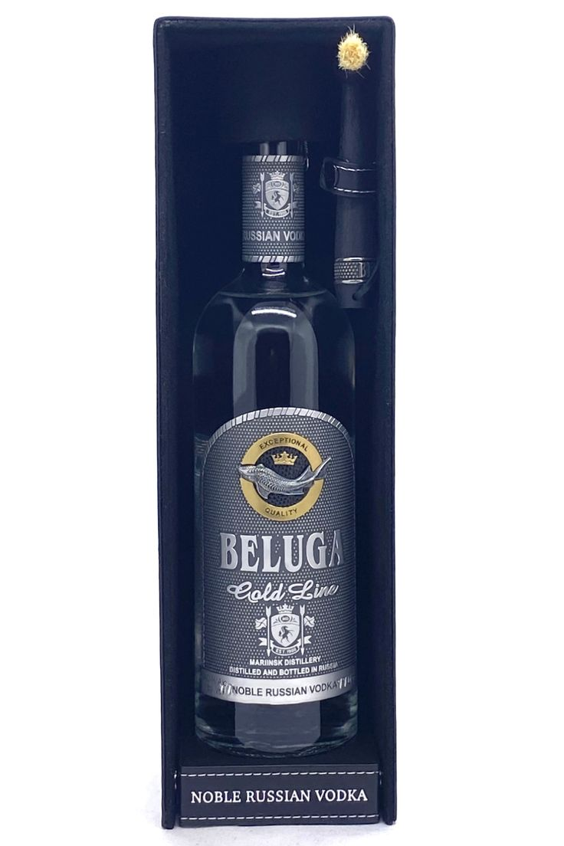

*"Vodka Beluga Gold Line (also known as Vodka Beluga hammer, hammer with one end is a small hammer and a brush head comes with a bottle of wine used to hit the wax head when opening the bottle) is the house's most premium beluga line. Mariinsky (founded in 1900) is a limited edition exclusively for wine connoisseurs around the world.Like Beluga Noble, the ingredients are also malt and water from a well in Sebiria but the production process The raw materials for production are more carefully selected and the best quality ones are used to produce Beluga.."*